React

Installation

Npm I -g create-react-app

Create-react-app uhk

If ur name has space so remove it by following command then run npm otherwise it will giv error

Npm config set cache “c:\user\usama~khan\folder”—global add tlda replace space

If u don’t wana install just run react so use

Npx create-react-app uhk

Public 🡪index.html where ur html which is added by other file using component

Src ->app.js where components are built

U have to import folling in app.js

*import* React, { Component } *from* 'react';

*import* Header *from* './components/Header'; its made by me manualy

*import* logo *from* './logo.svg';

*import* './App.css'; its css file

app.css its css file where u add ur css

index.js where u tell which component is renderd in to which html tag

*import* React *from* 'react';

*import* ReactDOM *from* 'react-dom';

*import* './index.css';

*import* App *from* './App';

*import* * *as* serviceWorker *from* './serviceWorker';//thisisused for offline loading

*import* 'bootstrap/dist/css/bootstrap.min.css'; /add bootstrap here by me

ReactDOM.render( //its takes tow component one is compnntn and 2nd is where u wana add this compont like html tag

  <React.StrictMode>

   <App /> //export default name which is in app.js file

  </React.StrictMode>,

  document.getElementById('root')

);

*// If you want your app to work offline and load faster, you can change*

*// unregister() to register() below. Note this comes with some pitfalls.*

*// Learn more about service workers: https://bit.ly/CRA-PWA*

serviceWorker.unregister();

pacakage .josn where all packages name writren and version as well

**node-module** where all packeges are install if u delete it u can dllt all akcege which is in side of t by typing npm istall it will install only thode package which is inisfd of it

components

there are two types of componnet one is function other s class

function is new class os old

**class**

**class App extends React.Component{**

**render(){**

**return(**

**<div className=”app”>**

**<h2>this is me</h2>**

**</div);**

**Export default App;**

**or u can writ it on start of class class App extends React.Component{**

**2nd way of clalss**

**class App extends React.Component{**

**render(){**

**return(**

**React.CreateElement(‘div’null,React.createElement(‘h2’,null’,”wao its nice”);**

**React.CreateElement(‘div’null,React.createElement(‘h2’, ,{className:’App’},**

**,”wao its nice”);**

**,{className:’App’},**

**function**

function App() {

   return (

     <div className="App">

      <h1>Bismillah hir rehman e reheem  ths is uhk</h1>

   </div>//   );// }

**u can use short cut by replace app.js with App.jsx**

**h1*5 other wise it will not word**

**how to add bootstrap**

**intall bootstap by**

**npm install react-bootstrap bootstrap**

**search react bootstrap then add**

**either cdn link or import in to index.js**

**first u have to install it by using npm install react bootstrap**

**header=incorrorect it act as tag**

**Header =correct act as component**

**<img/>its closing tag if u dint /in end so it will give error in closing tag html pick it by self if u don’t put but not react**

**Path**

**C:\Users\Usama Khan\Videos\React-learning-by -uhk\React-learning\uhk2>**

**C:\Users\Usama Khan\Videos\React-learning-by -uhk\React-learning\uhk2>**

**Add components files**

**Add folder to src**

**Person ->persn.js**

**In person .js**

**U have to create componntn u can create class compont function cpmponnt or arrow finction component**

**Fist add**

**Import React from ‘react’**

**Var person =()=>{**

**Return(<h1>nice</h1>);**

**Export Default person**

**Now add this in to app.js <person/> or <person><person/>,fosrt add this compontn**

**Import person from ‘.person/person’; person.js don’t need to write js it pick automatic**

**Props**

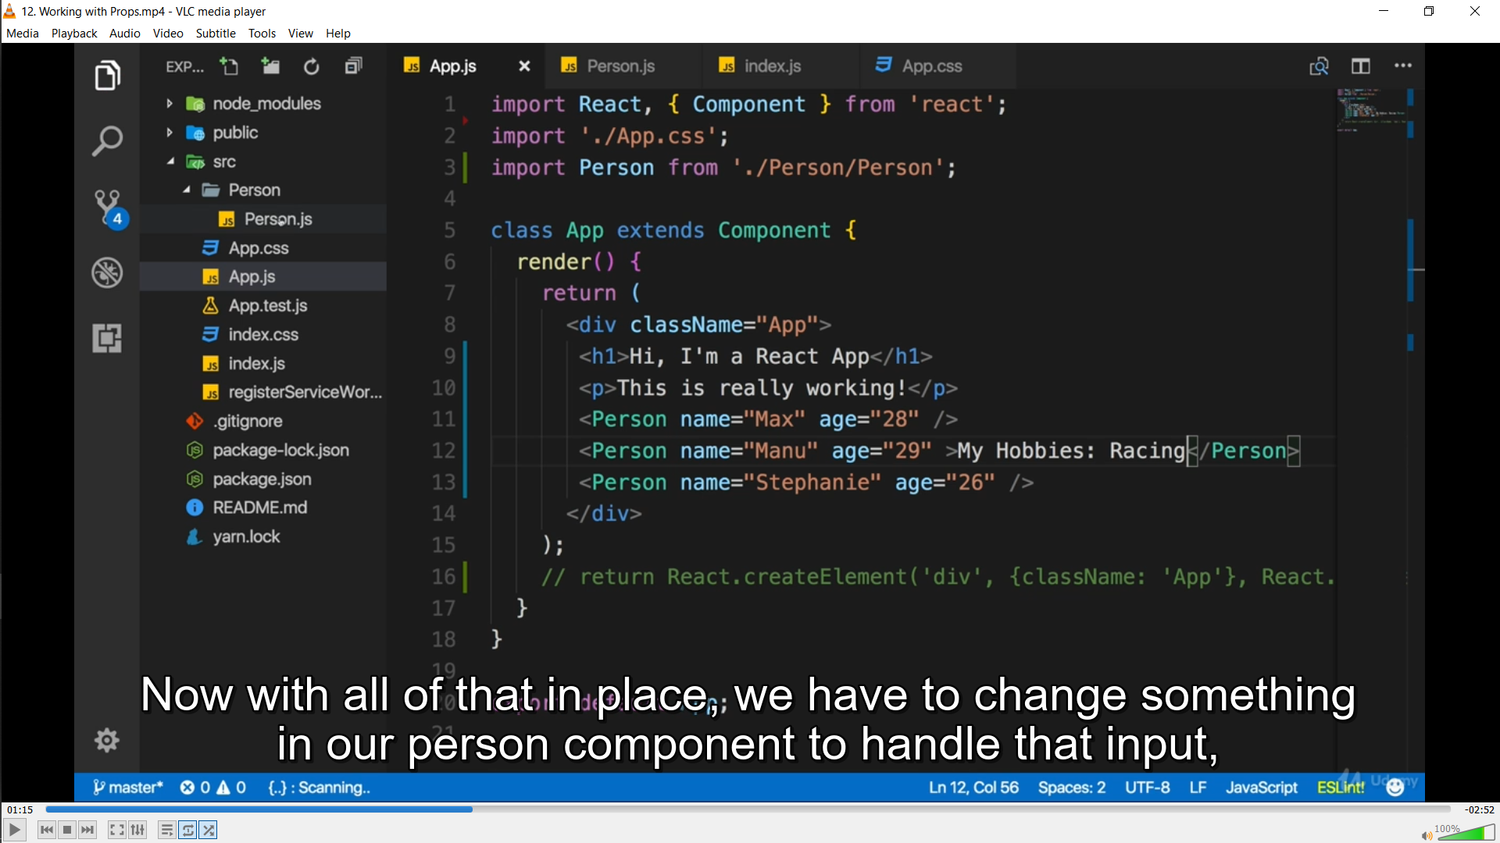

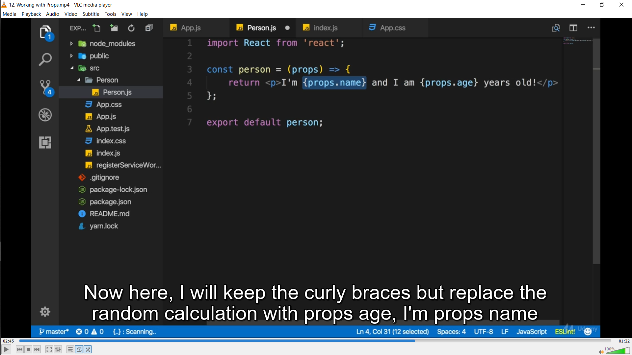

**Children prop**

**State and children**

 state={

        person:[{

          name:"usama",

          age:"21"

        }]

      }

  render(){

*return*(

      <Person name={this.state.person[0].name}e>nice work</Person>

    );

  }

Component name person

Var person =(prop)=>{

<h1>prop.name</h1>

<h1>{prop.children}//it will ick inside person element wich is nice work

Its works in side class only

We can pass value by 3 way , hooks,

state and props

Now set state

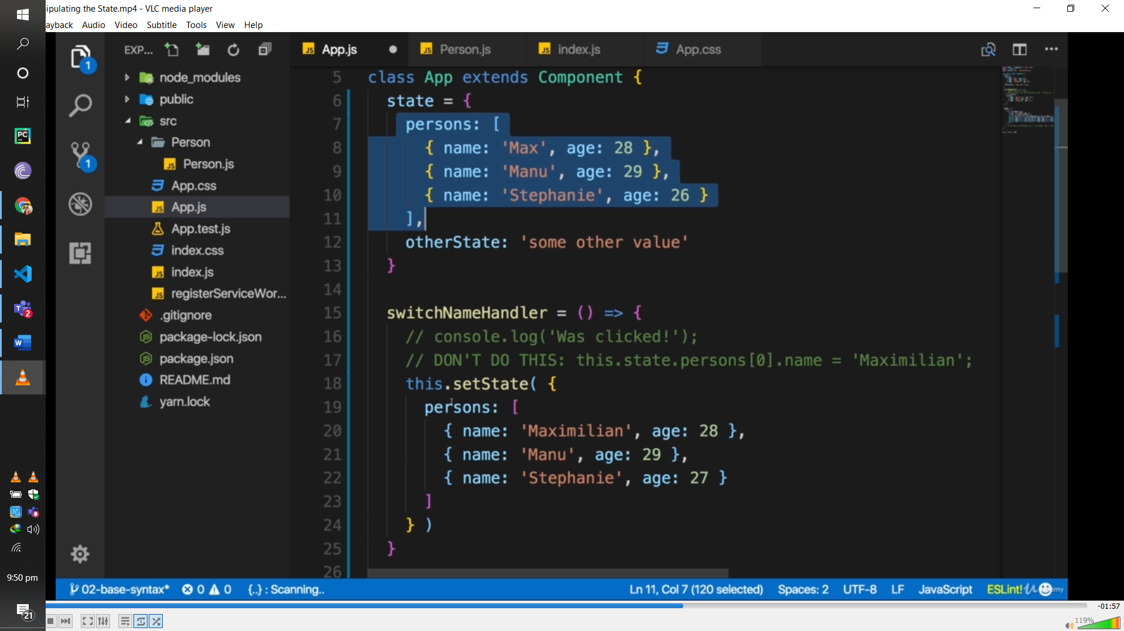

**Onclick**

**Function**

 btnHandler =()=>{

    this.setState({

      person:[{name:"uhkharry1",age:"232"}],

      person2:"wll"

    })

  }

<button  onClick={this.submitButtonHandler} >Link</button>//don’t need to pss() here like css

**This keyord is use in class only/**

**React hook**

**State is used in class only**

**So with the help of react hook**

**UseState import and then use in function**

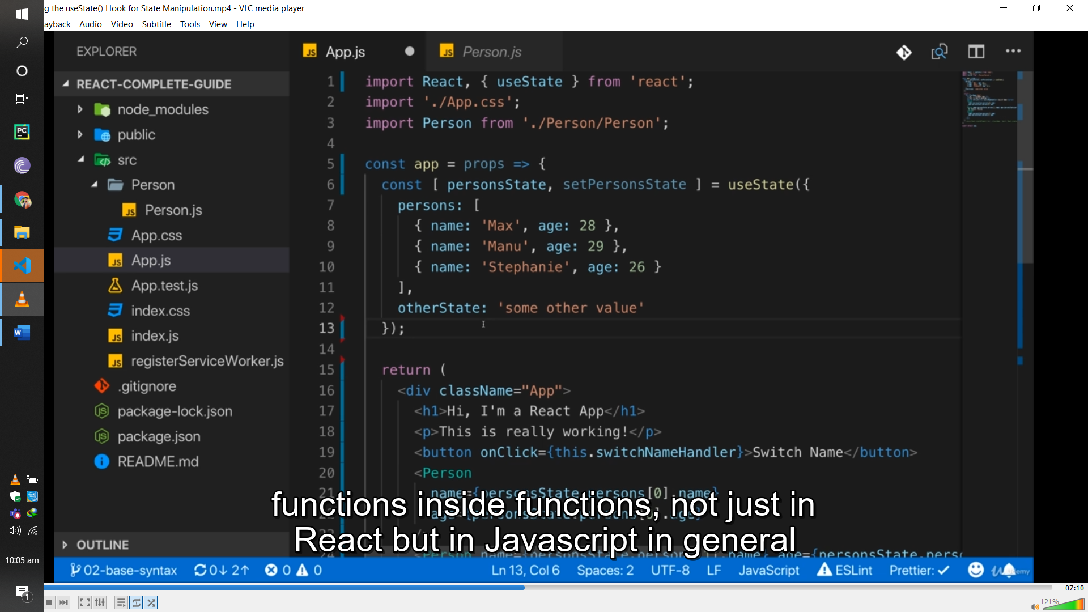 **u have to import usestate**

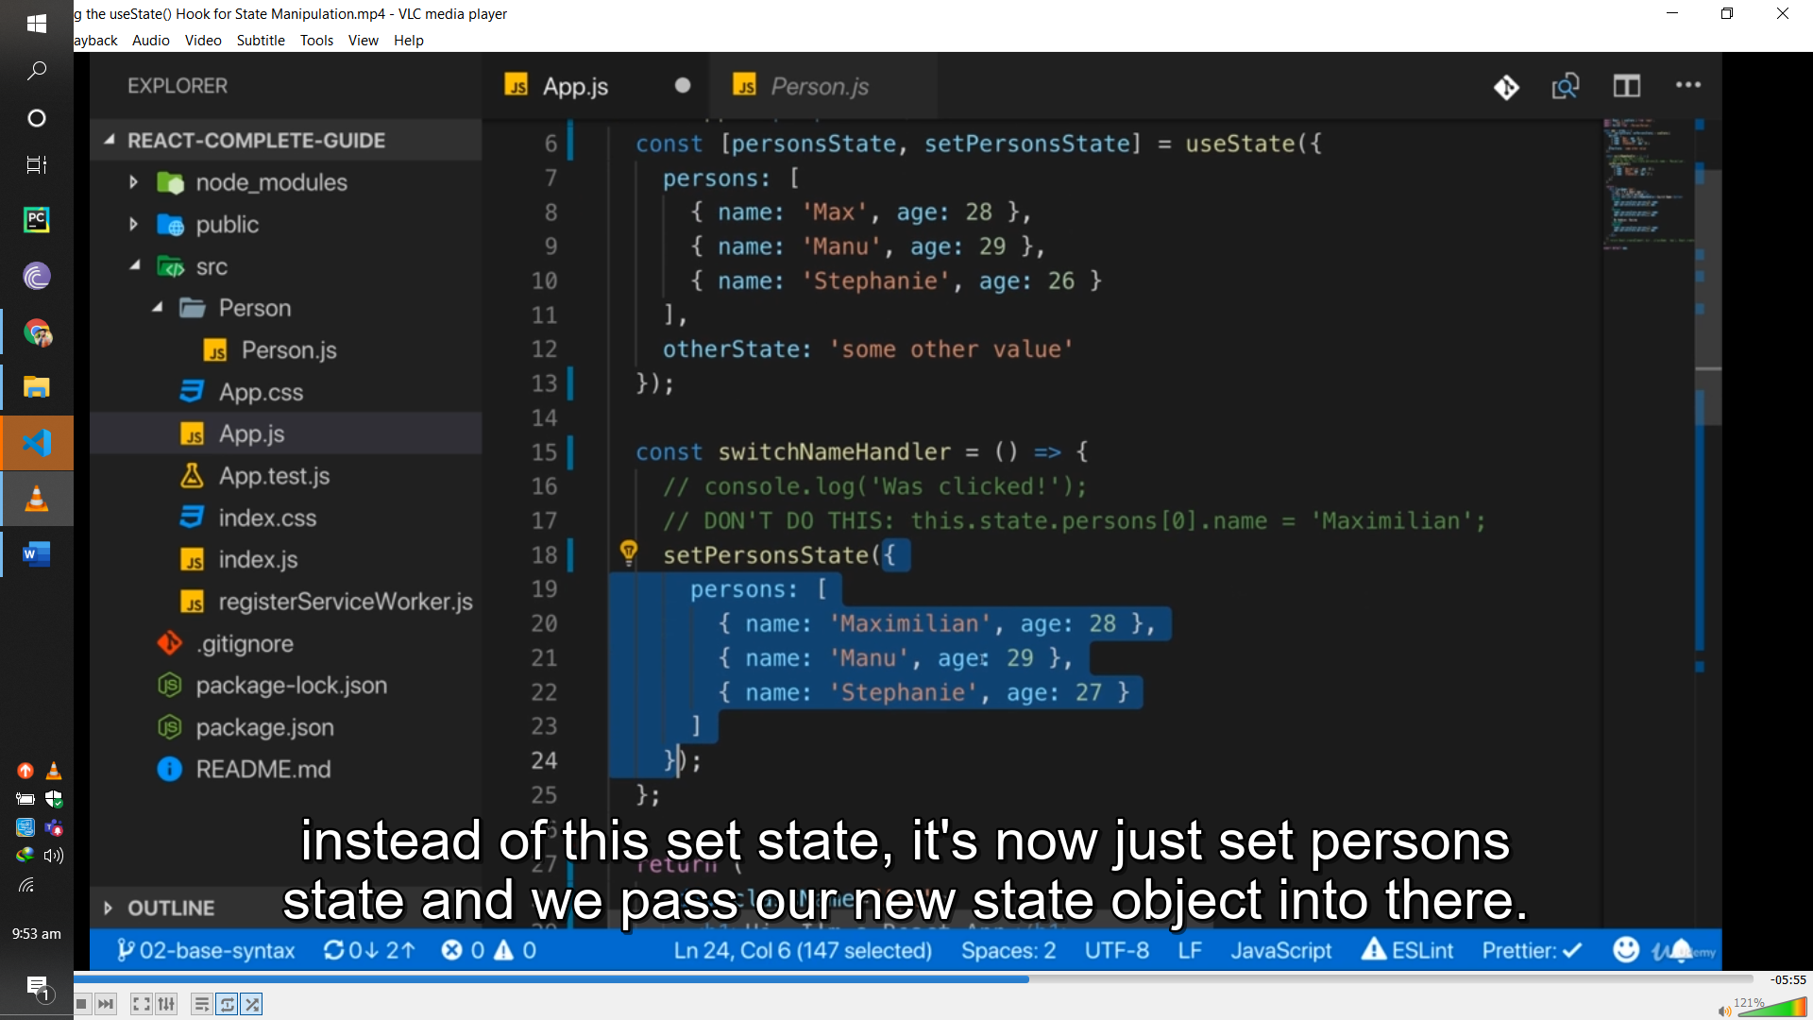

**Passing in to own tag as wll**

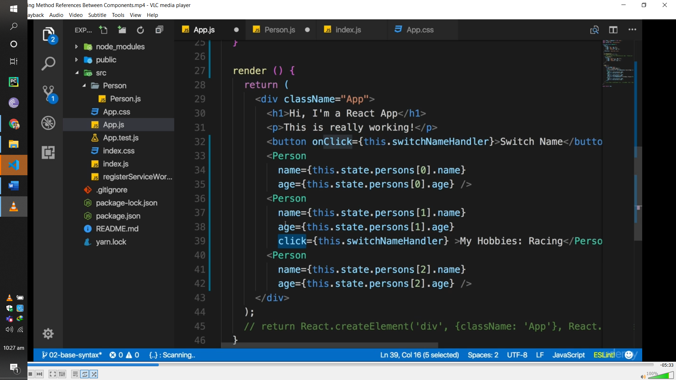

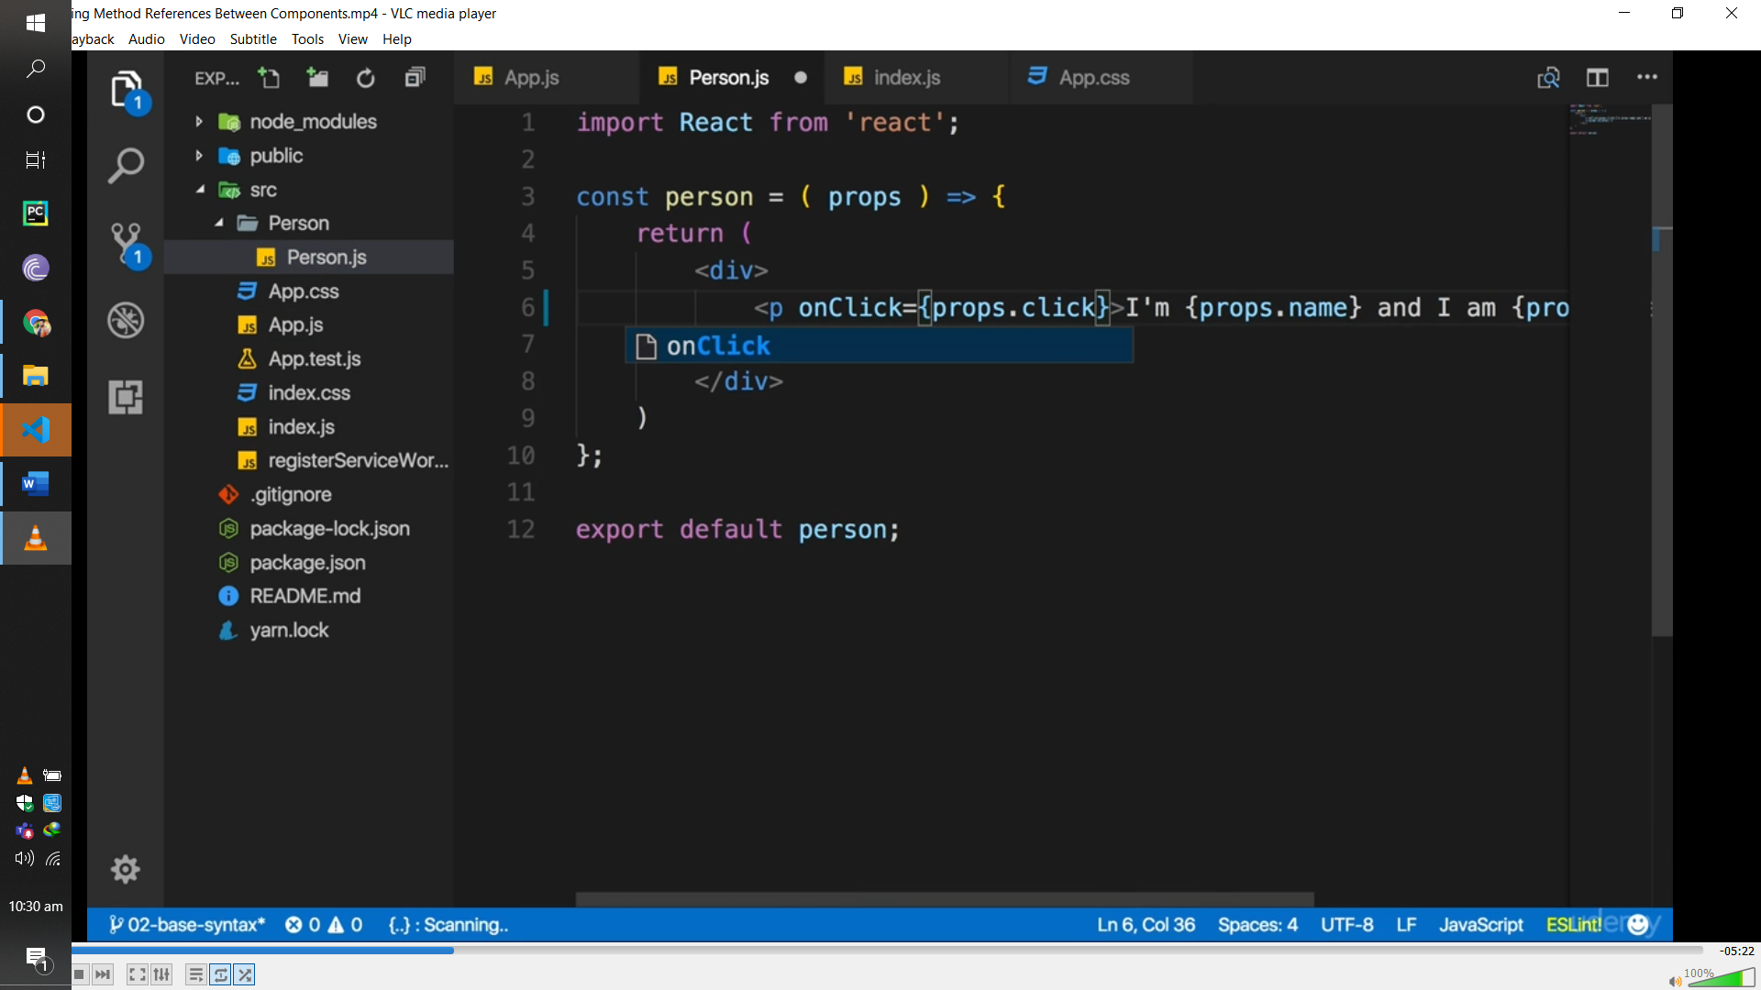

**In hook u have to add bind in function**

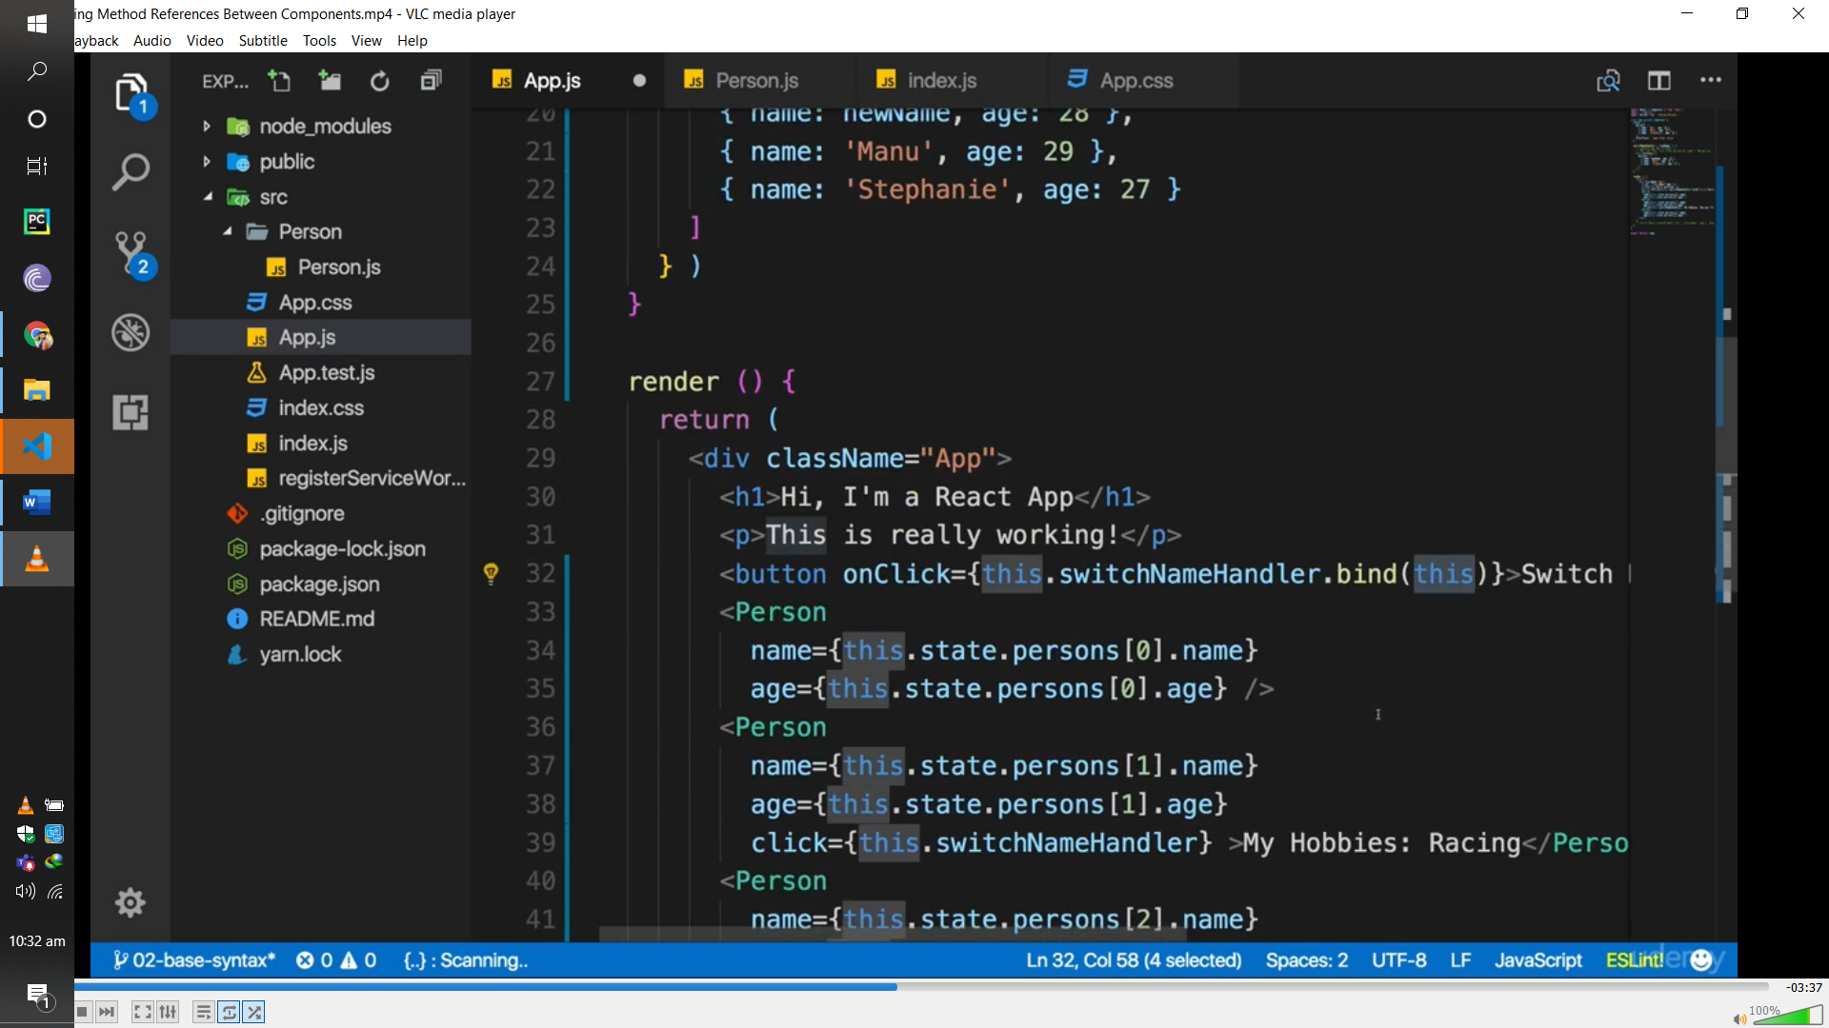

**If u pass parameter in fnction so u have to call as**

**<button onClick={thos.switchNameHandler.bind(this,”max”)}**

**Now u can use arrow fubction as wll**

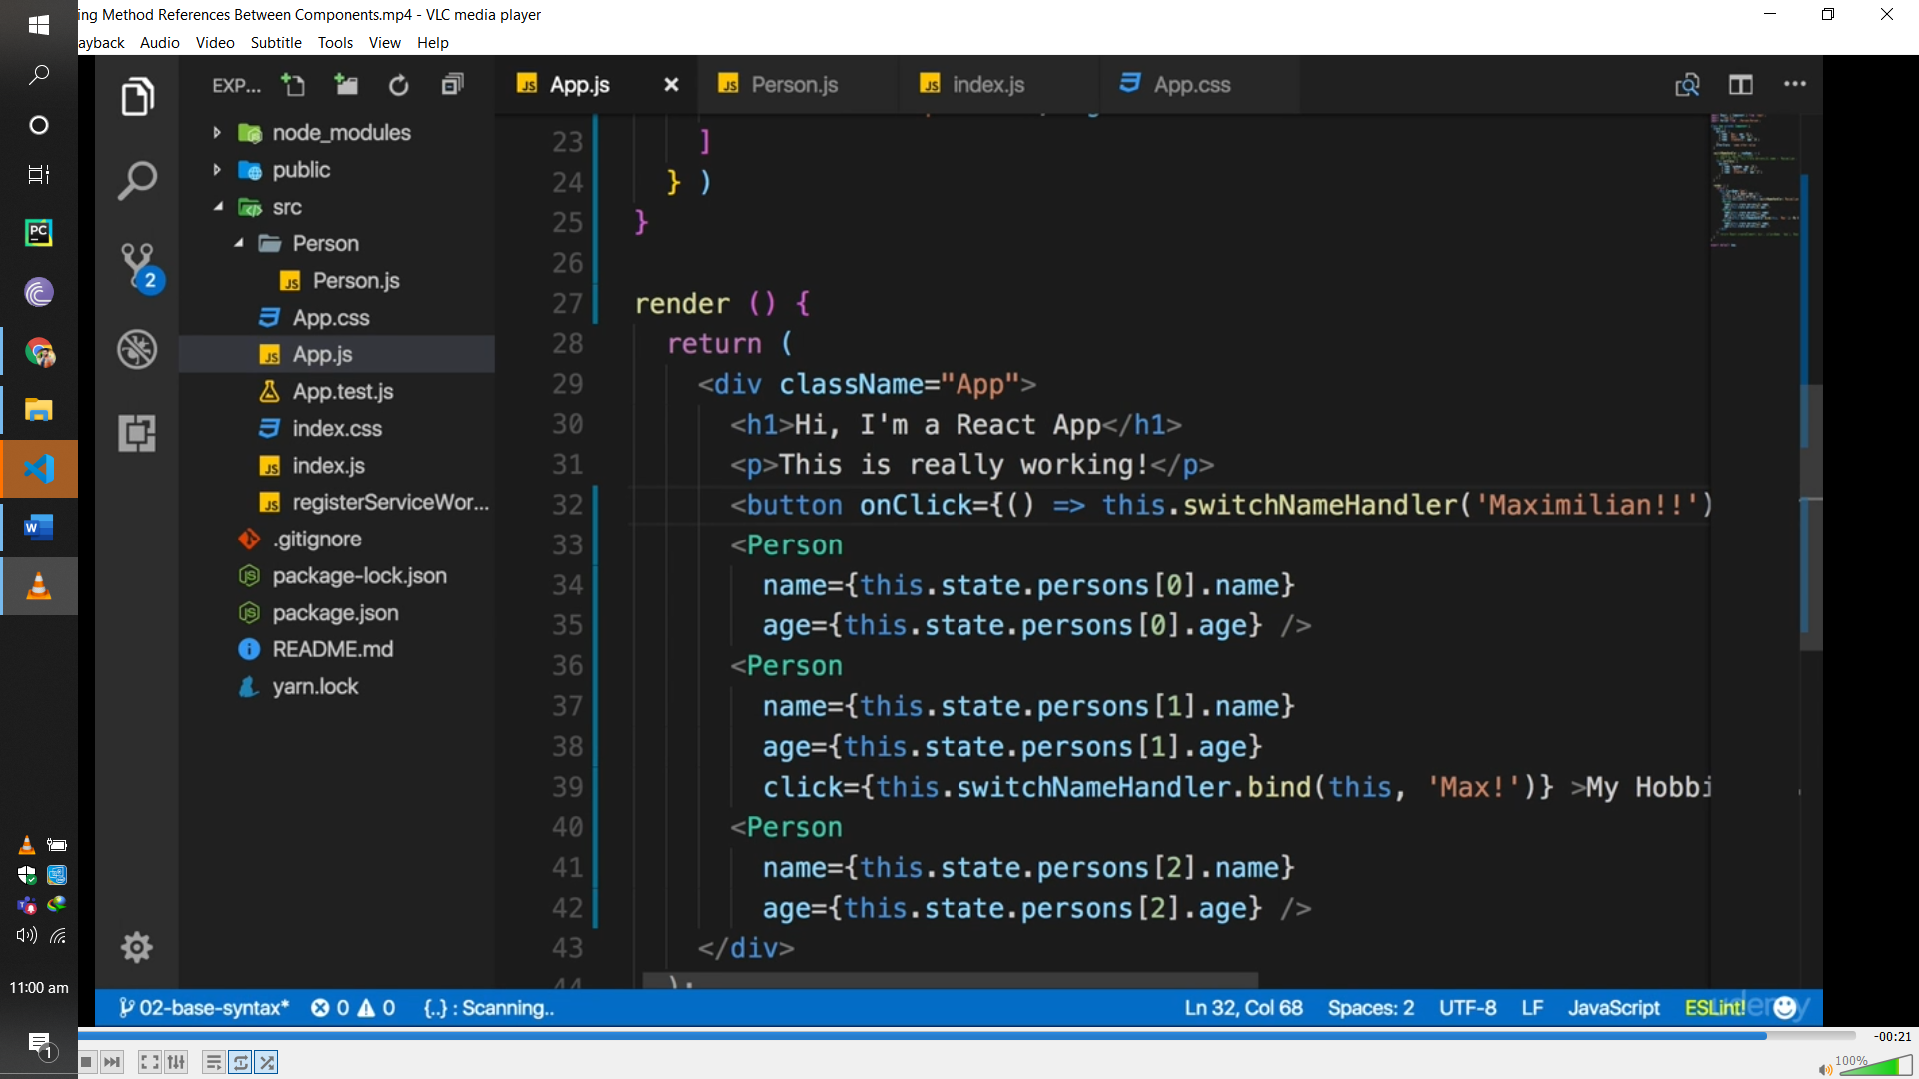

**Input change**

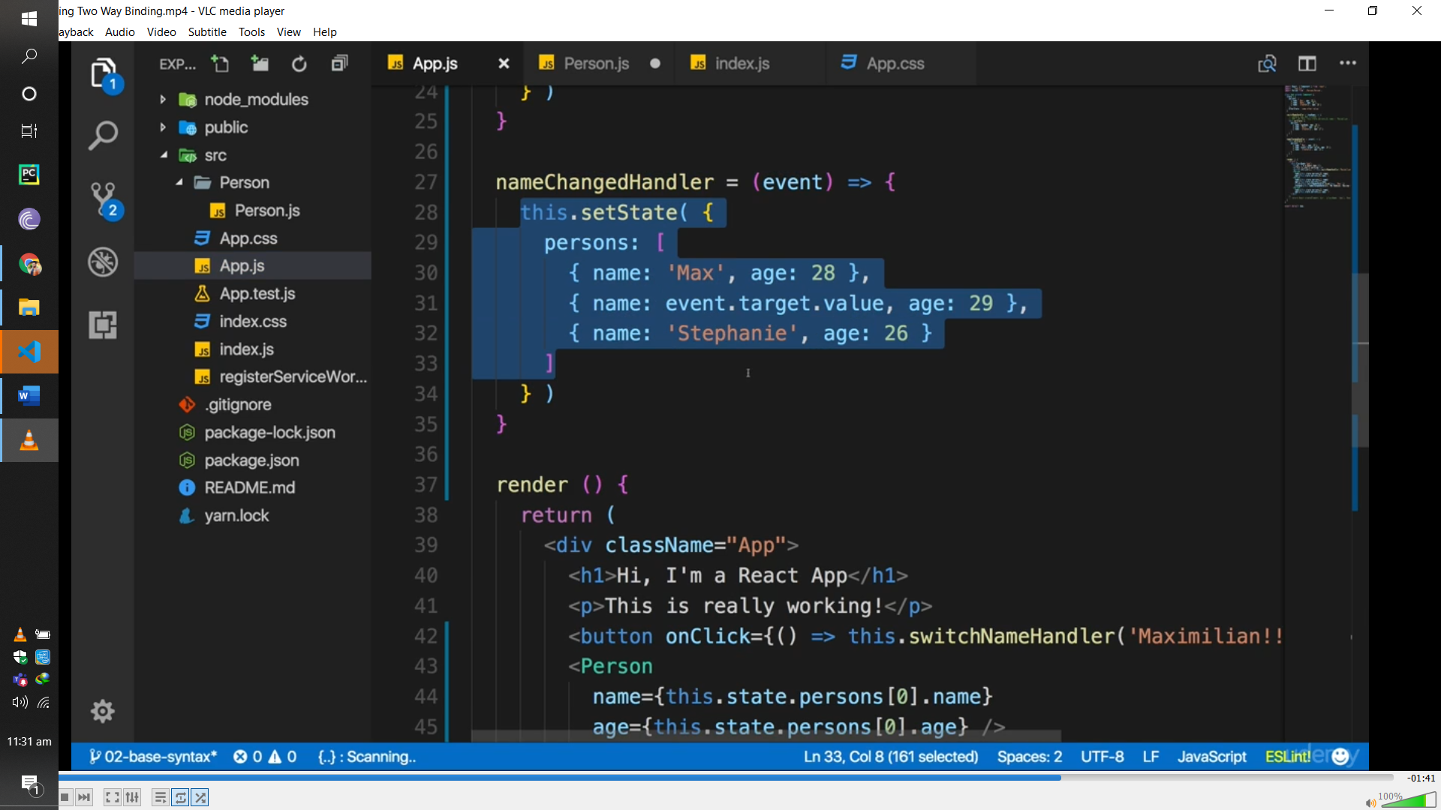

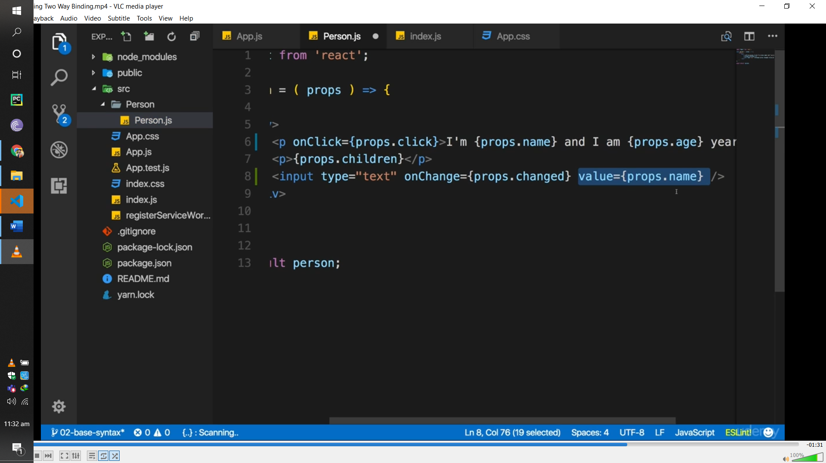

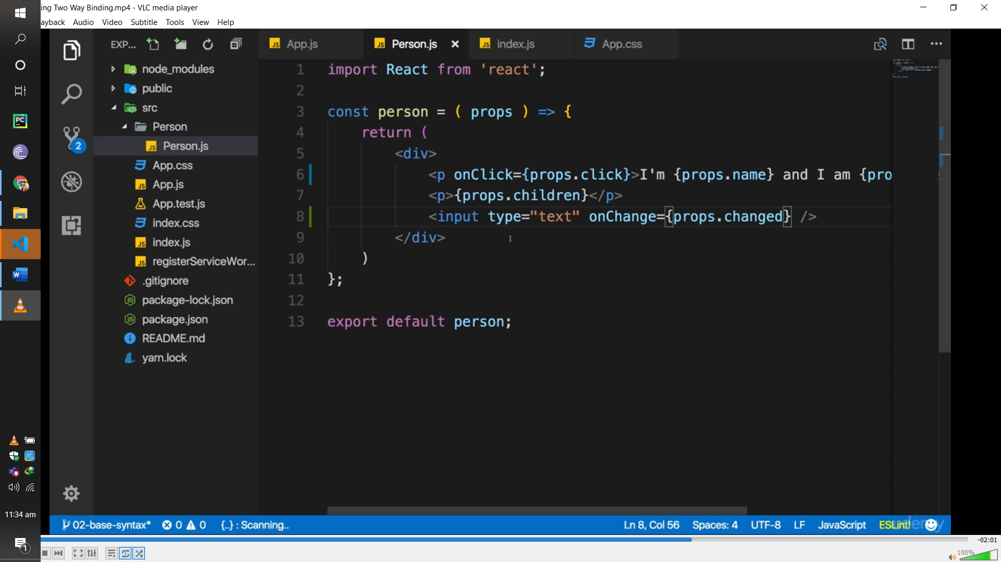

**Styling**

**U have compont folder person which u created by own and then add file name person .css and then stylin in it and then import in to app..jss and use that stling here its work globally**

**Us have to adde xtion css by default js extionsjons**

**Inline styling**

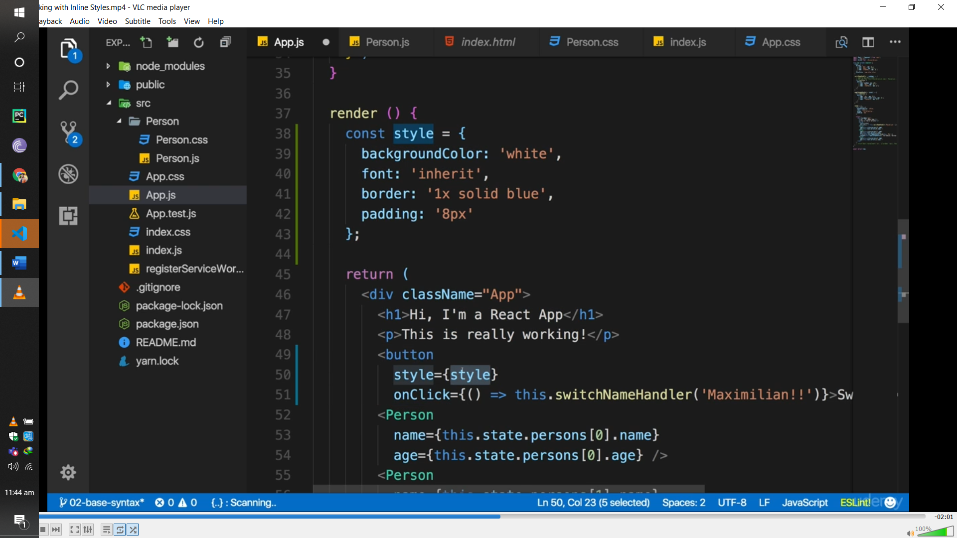

**It will apply only n respective button**

**Its inlne stylng**

**State and prop mix**

**App.js**

state={

    person:[{name:"uhkharry",age:"23"}],

    person2:"nice"

  }

  render(){

*return*(

      <>

      <h1>this is class programming</h1>

      <Person name="uhk" />

      <Person  name ="ali">this is me</Person>

      <Person >this is me  {this.state.person[0].name}</Person>

      <Person >this is me  {this.state.person2}</Person>

      </>

    );

  }

}

**Compontn**

var Person=(props)=>{

*return*(

  <><h1>{props.name}</h1>

    <h2> {props.children}</h2>

    </>);

}

**Hooks**

import React, { useState } from "react";

export default function Button() {

const [buttonText, setButtonText] = useState("Click me, please");

return (

<button onClick={() => setButtonText("Thanks, been clicked!")}>

{buttonText}

</button>

);

}

**This keyword is not use n hooks**

*import* React , {useState} *from* 'react';

*import* logo *from* './logo.svg';

*import* './App.css';

*import* Person *from* './person/person';

  const App=(props)=>{

  const [personState,newpersonState]=useState({

    person:[{name:"uhkharry",age:"23"}],

    person2:"nice"

  });

   const btnHandler =()=>{

    newpersonState({

      person:[{name:"uhkharry1",age:"232"}],

      person2:"wll",

    });

  }

*return*(

 <>

    <h1>{personState.person[0].name}</h1>

    <button onClick={btnHandler}>btnn</button>

    <Person/>

    </> );

  }

*export* *default* App;

**if two component**

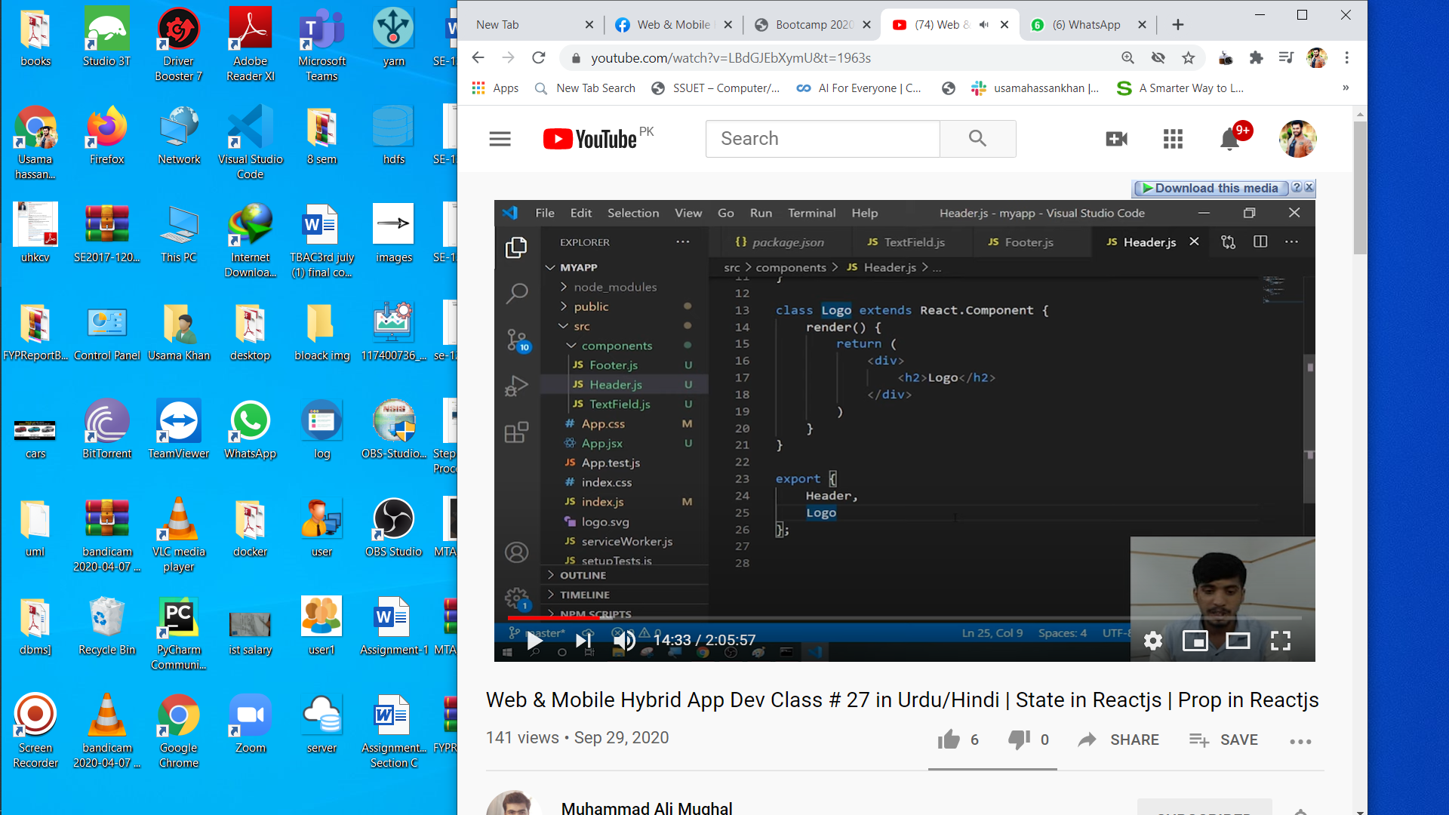

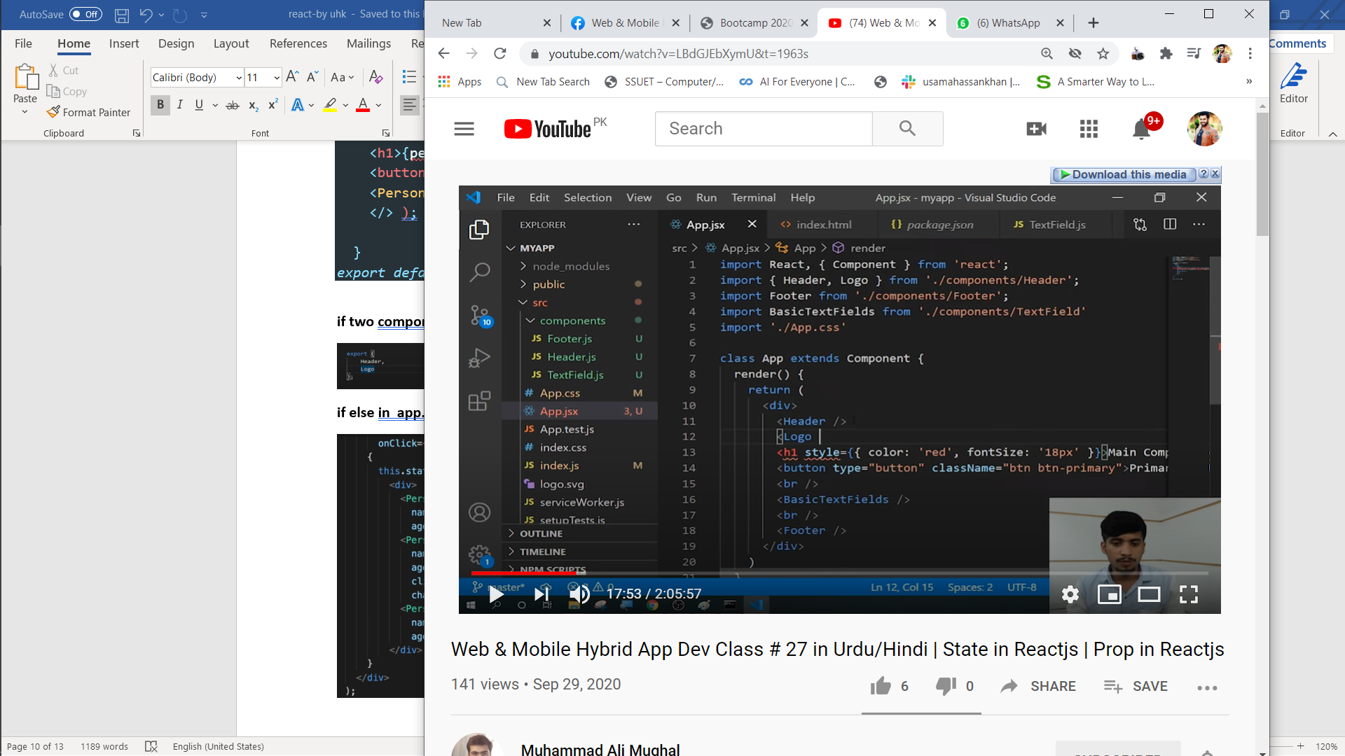

**if else in app.js with state**

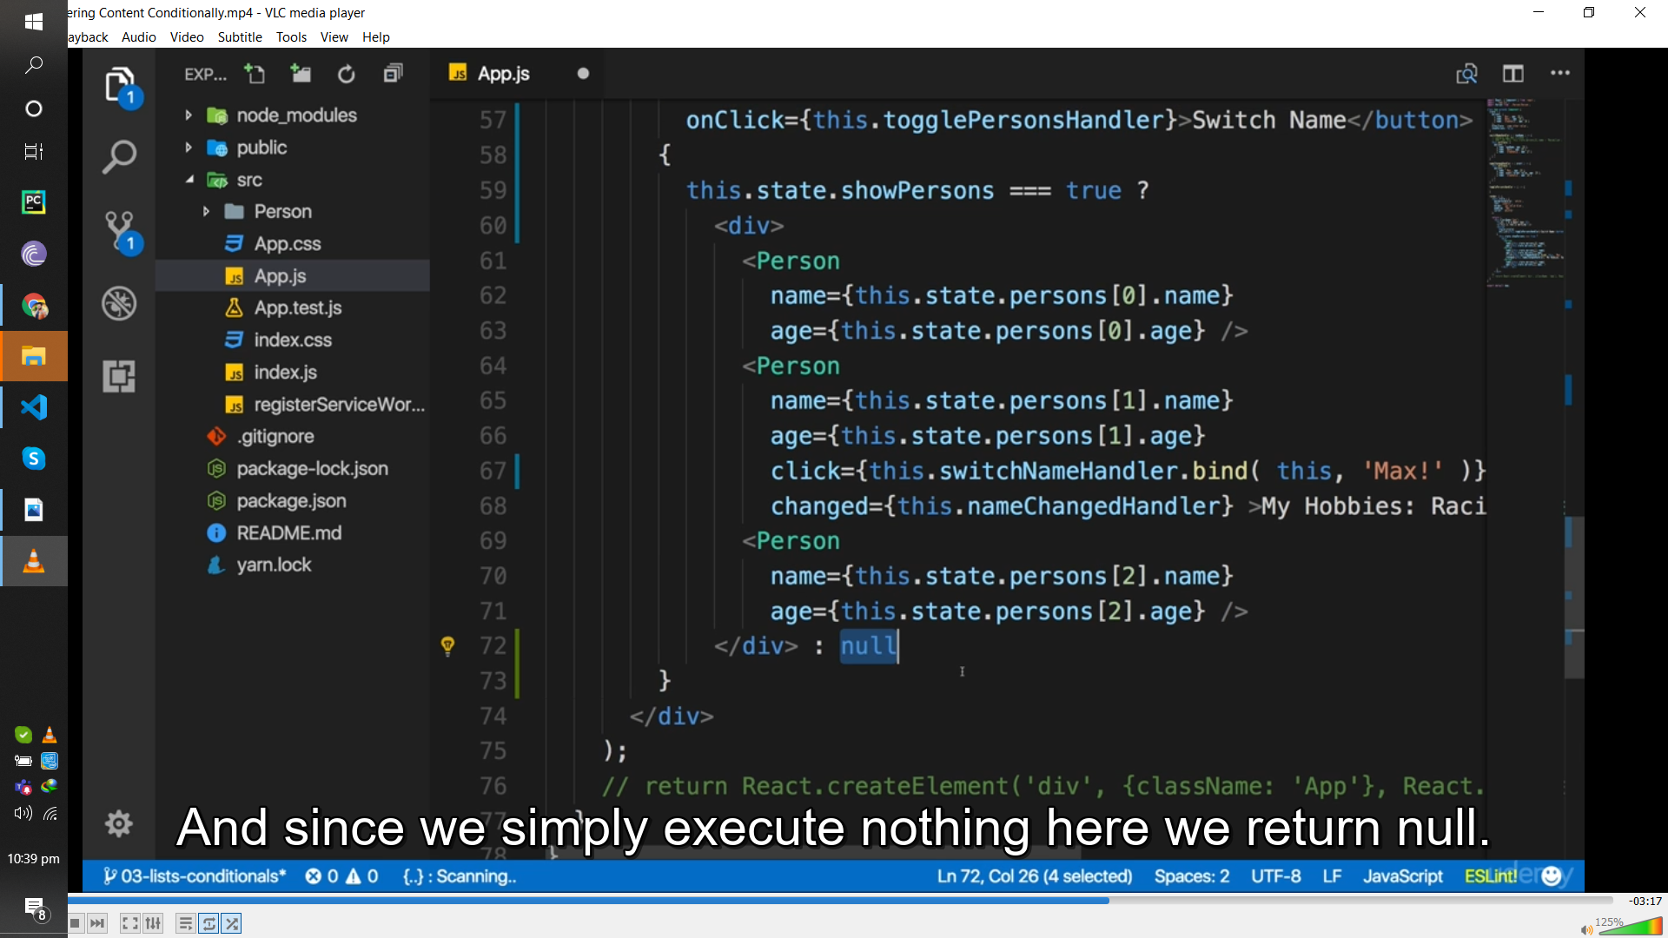

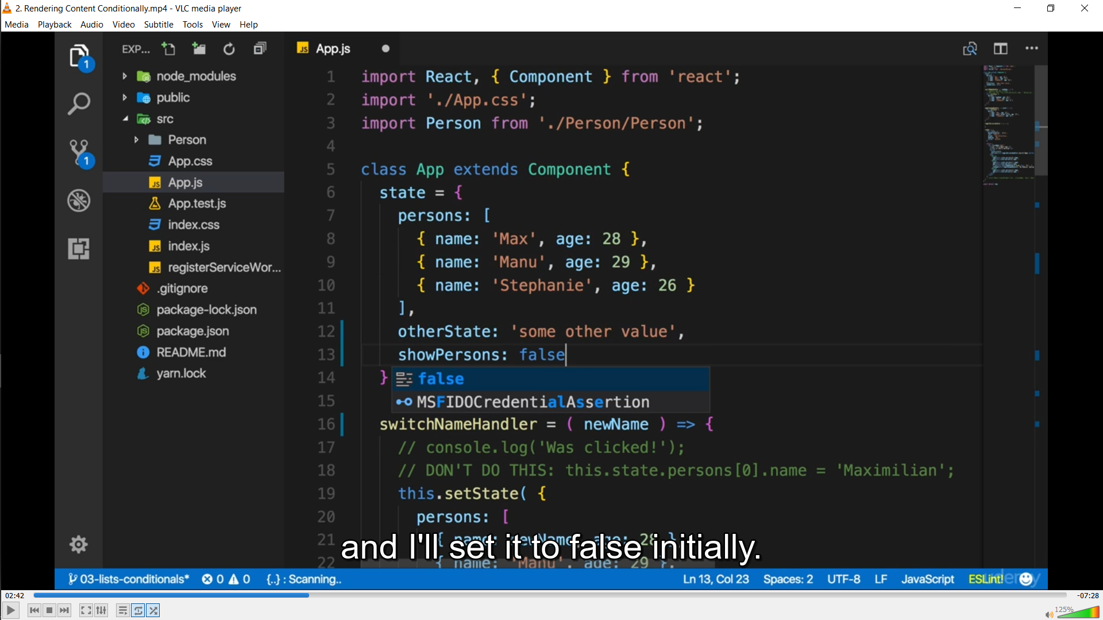

**If else**

import React, { Component } from 'react';

import './App.css';

import Person from './Person/Person';

class App extends Component {

state = {

persons: [

{ name: 'Max', age: 28 },

{ name: 'Manu', age: 29 },

{ name: 'Stephanie', age: 26 } ],

otherState: 'some other value',

showPersons: false }

switchNameHandler = ( newName ) => {

// console.log('Was clicked!');

// DON'T DO THIS: this.state.persons[0].name = 'Maximilian';

this.setState( {

persons: [

{ name: newName, age: 28 },

{ name: 'Manu', age: 29 },

{ name: 'Stephanie', age: 27 } ] } ) }

nameChangedHandler = ( event ) => {

this.setState( {

persons: [

{ name: 'Max', age: 28 },

{ name: event.target.value, age: 29 },

{ name: 'Stephanie', age: 26 } ] } ) }

togglePersonsHandler = () => {

const doesShow = this.state.showPersons;

this.setState( { showPersons: !doesShow } );

}

render () {

const style = {

backgroundColor: 'white',

font: 'inherit',

border: '1px solid blue',

padding: '8px',

cursor: 'pointer' };

let persons = null;

if ( this.state.showPersons ) {

persons = (

<div>

<Person

name={this.state.persons[0].name}

age={this.state.persons[0].age} />

<Person

name={this.state.persons[1].name}

age={this.state.persons[1].age}

click={this.switchNameHandler.bind( this, 'Max!' )}

changed={this.nameChangedHandler} >My Hobbies: Racing</Person>

<Person

name={this.state.persons[2].name}

age={this.state.persons[2].age} />

</div>

); }

return ( <div className="App">

<h1>Hi, I'm a React App</h1>

<p>This is really working!</p>

<button

style={style}

onClick={this.togglePersonsHandler}>Toggle Persons</button>

{persons}

</div>

);

// return React.createElement('div', {className: 'App'}, React.createElement('h1', null, 'Does this work now?'))}}

export default App;

replace above in to map arrow function

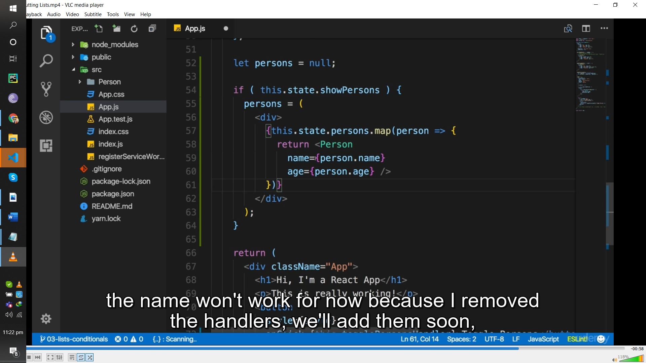

Dlting

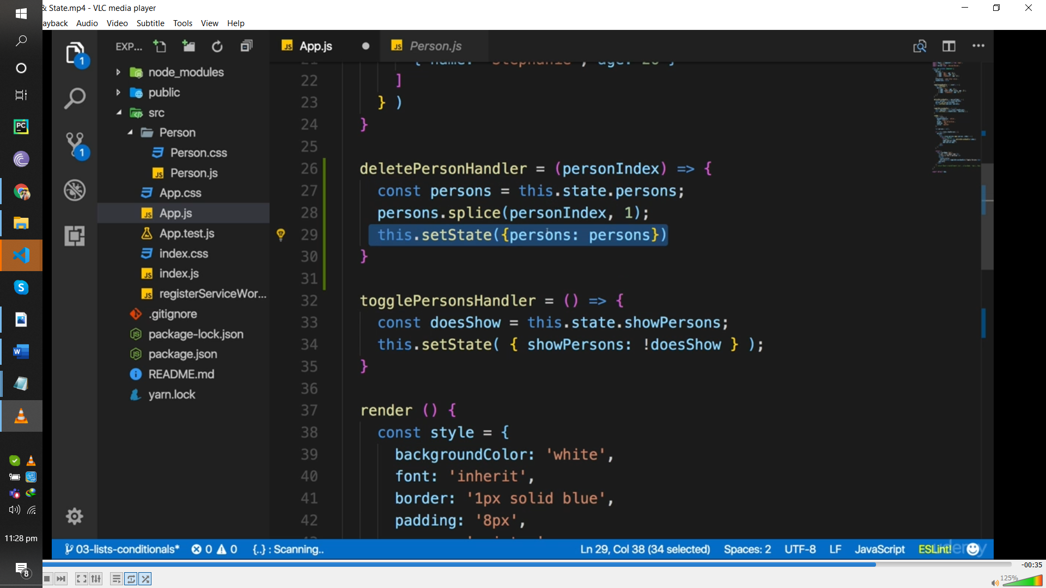

Here u r changing actual array that’s not good prative use spread operator or slice expamale are give in 2 pics ABOVE

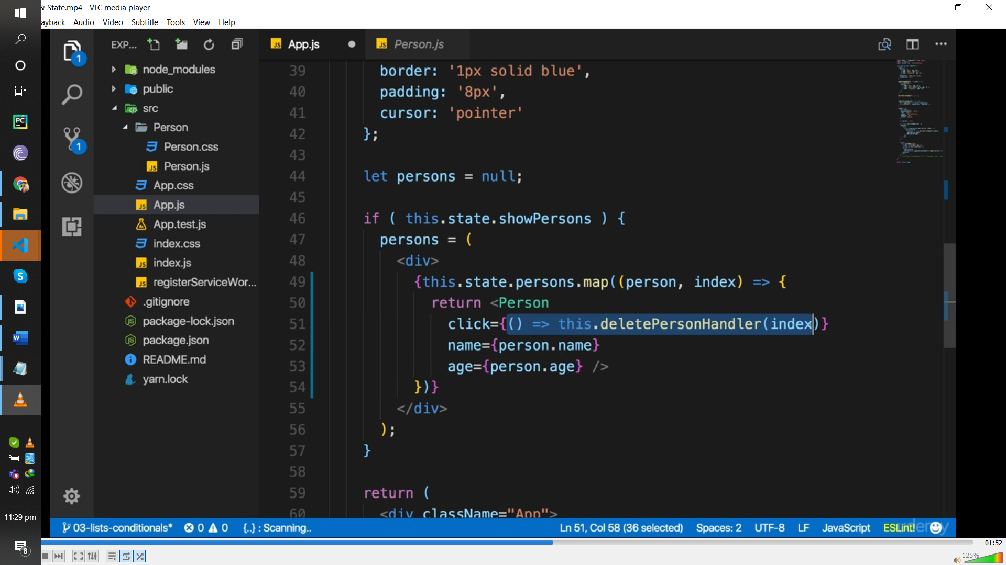

Component which I created name person

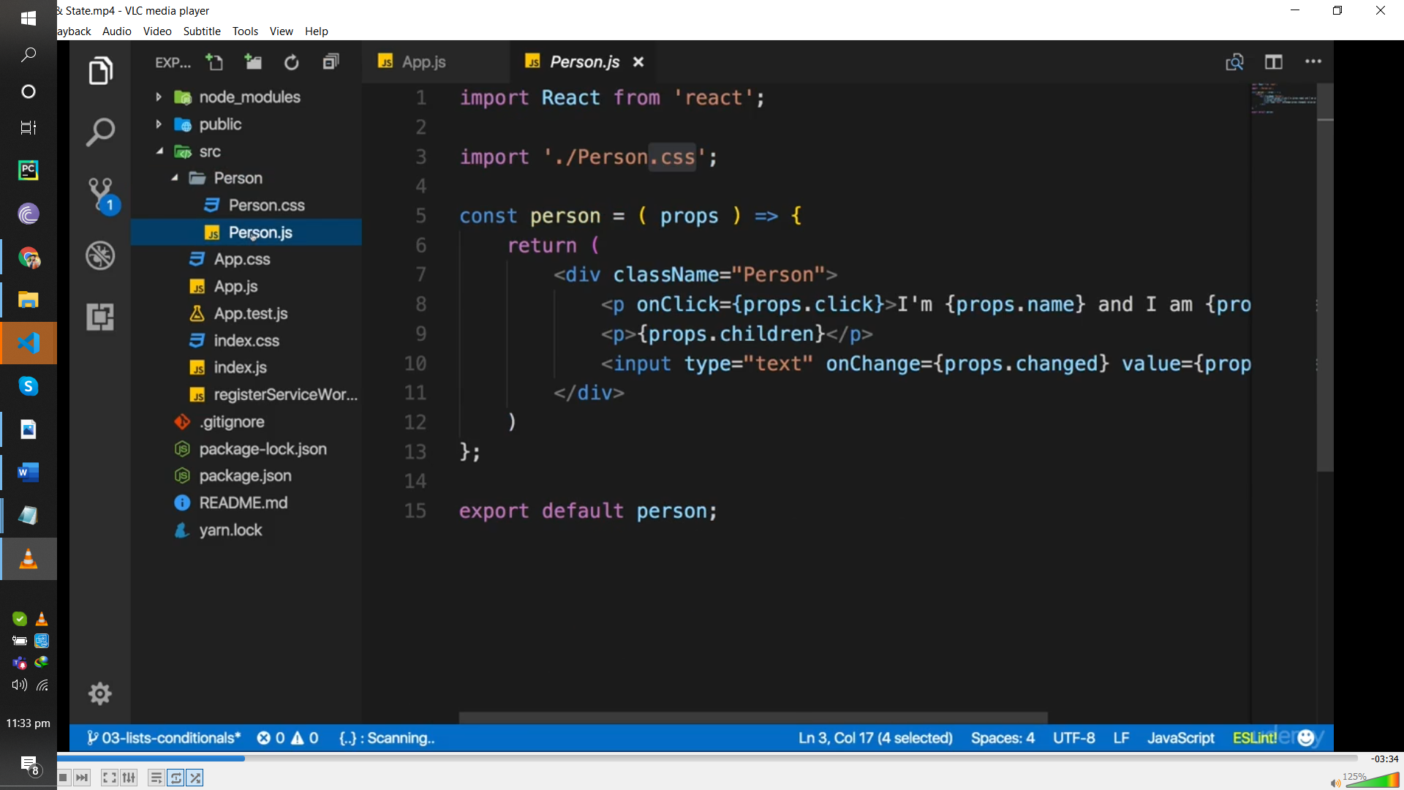

Here splice rmoe 1 value form last

In jhook bind dostnit work it wokks as bind here

Lile this.deeltePersonal Handle.bind(this)

**EXAMPLE**

here u are change acuutal array by splicing its bettr to mae copy and change that

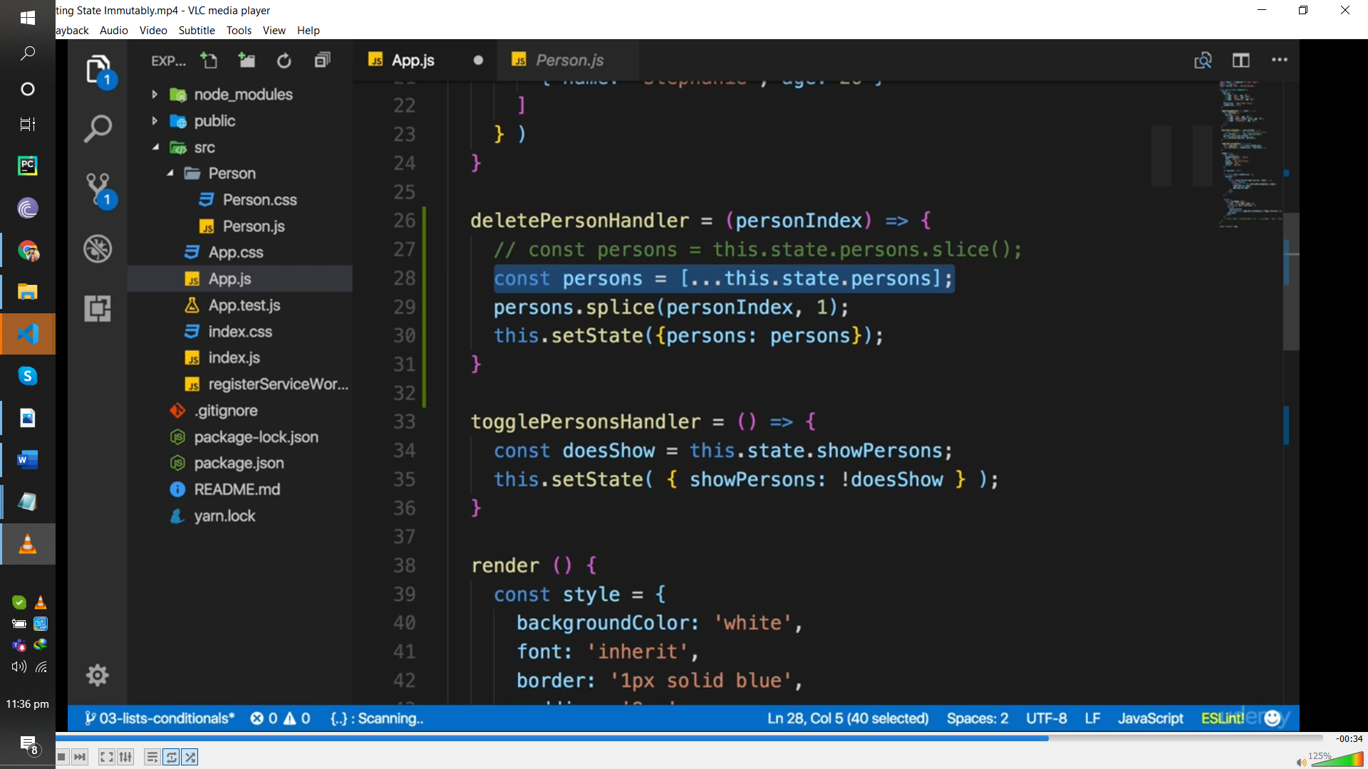

USE KEY OF MAP OTHER WISE ERROR IN CONSOLE

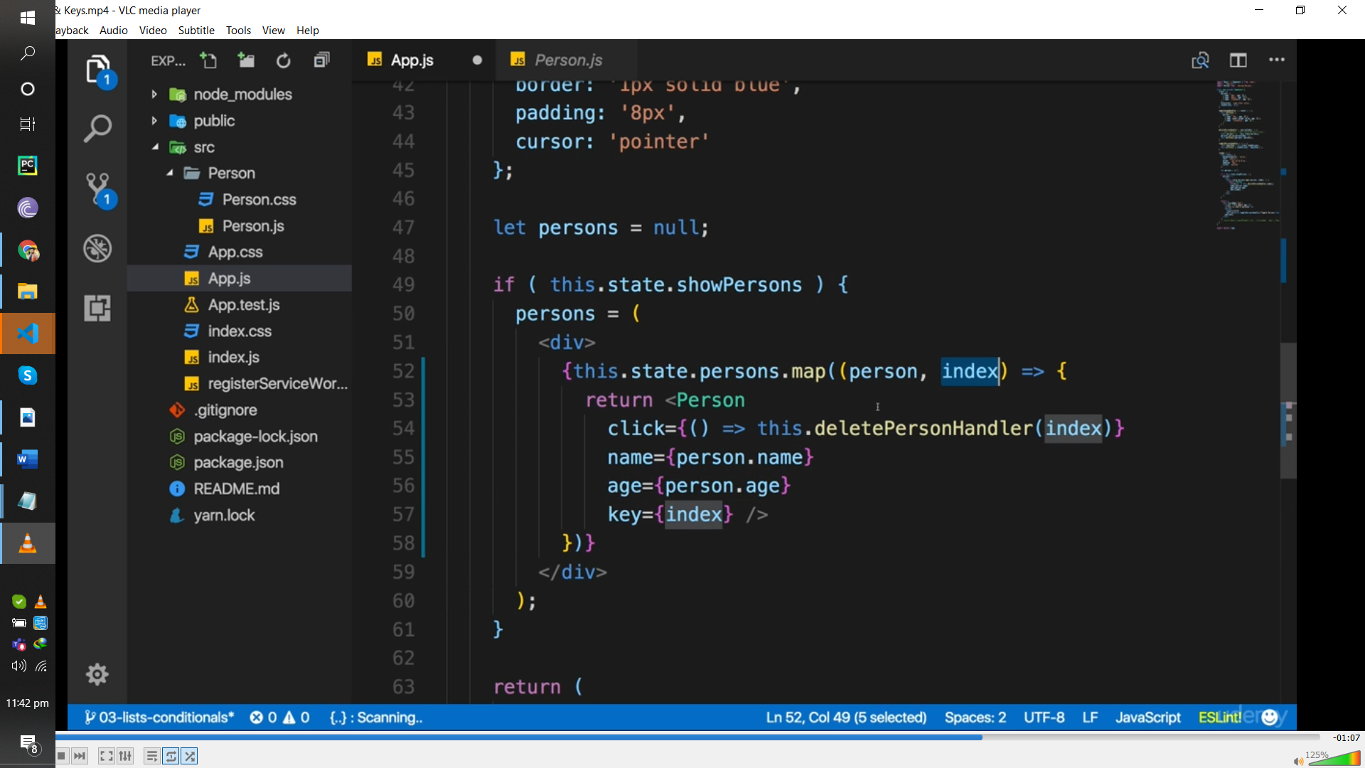

BT ITS NOT GOD PRACTICE USE id of uniqie

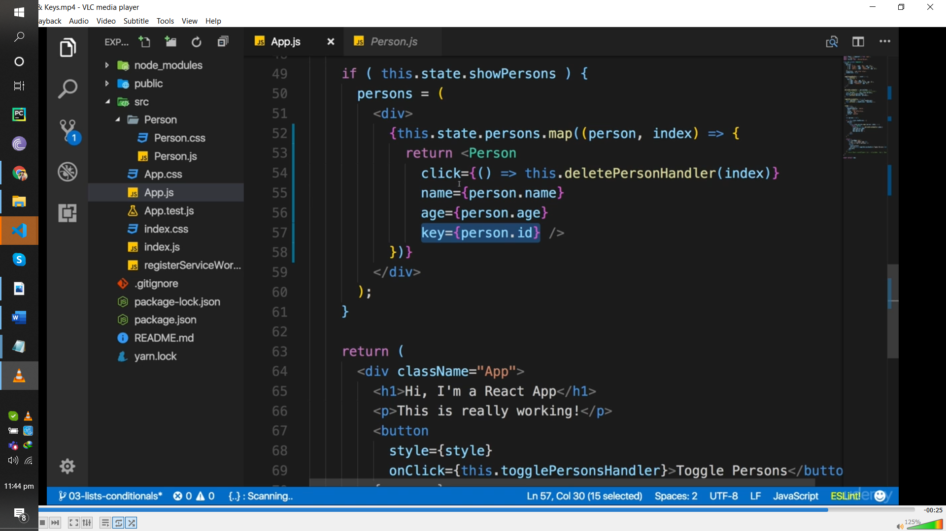

c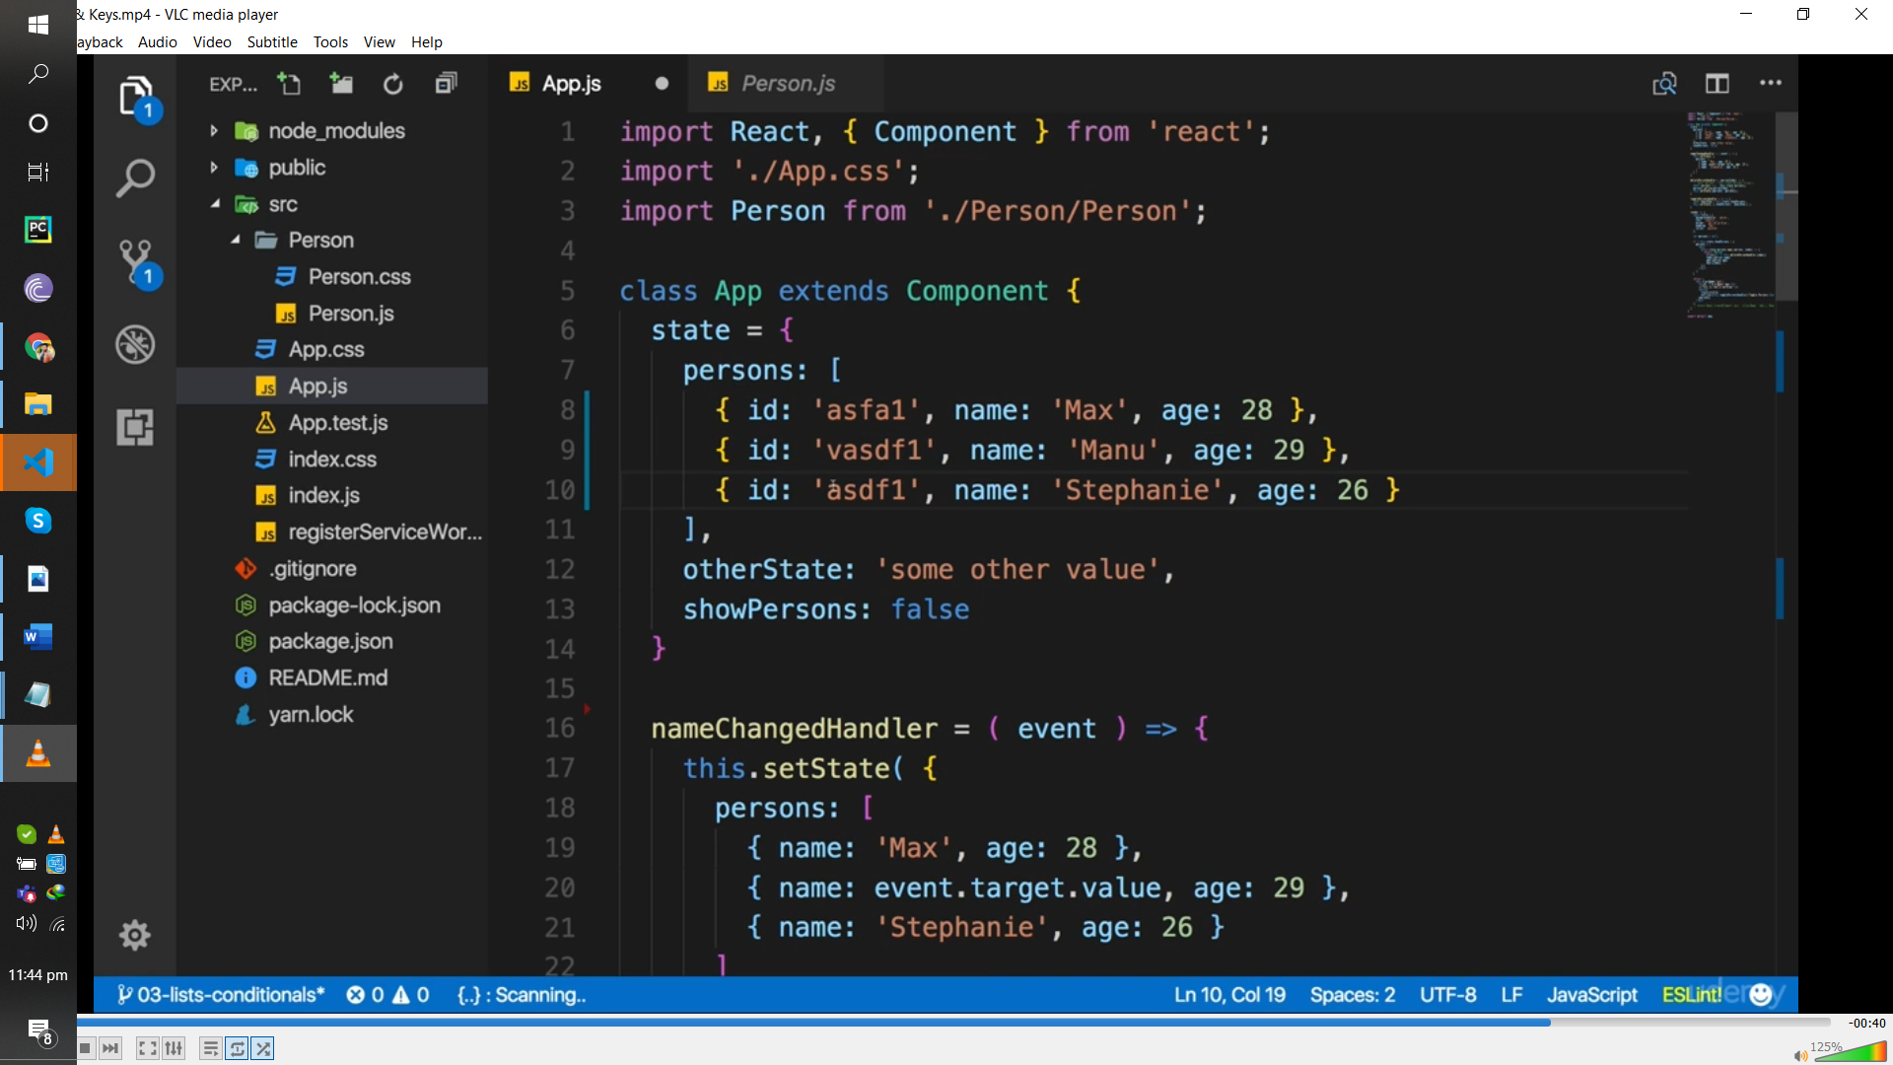

syle.backgronc=’red’;

